**Designing a seven segment display to output numerals using Quartus 2**

20/2/2016

CE Lab – 5,

*Time worked on lab: 4 hours approx*

**Purpose:**

The purpose of this lab is to understand how we can construct a seven-segment display to output numerals using Quartus 2 and an Altera DE 2 board.

**Components used:**

Software’s: Quartus 2, ModelSim

Hardware: computer, Altera DE2 Board

**Table:**

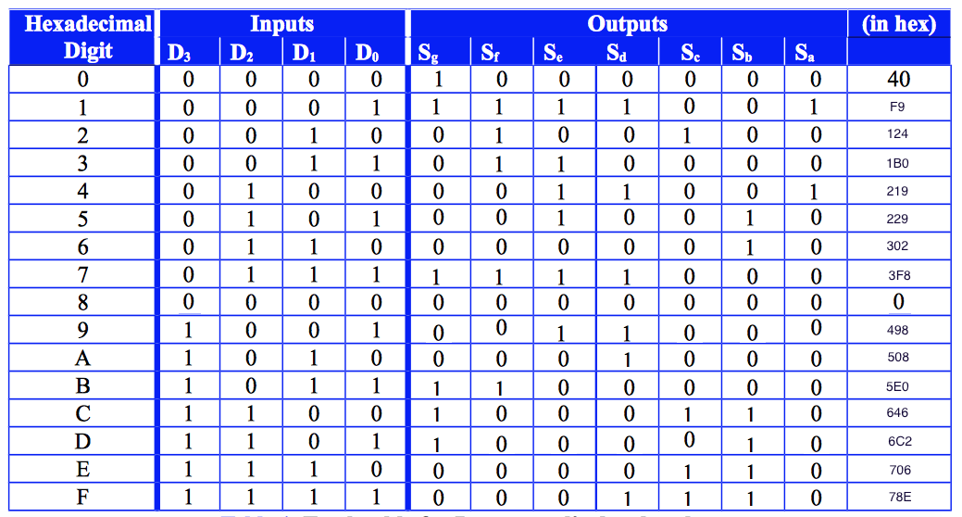

**Equations:**

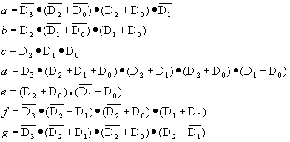

**Sketch and Design process :**

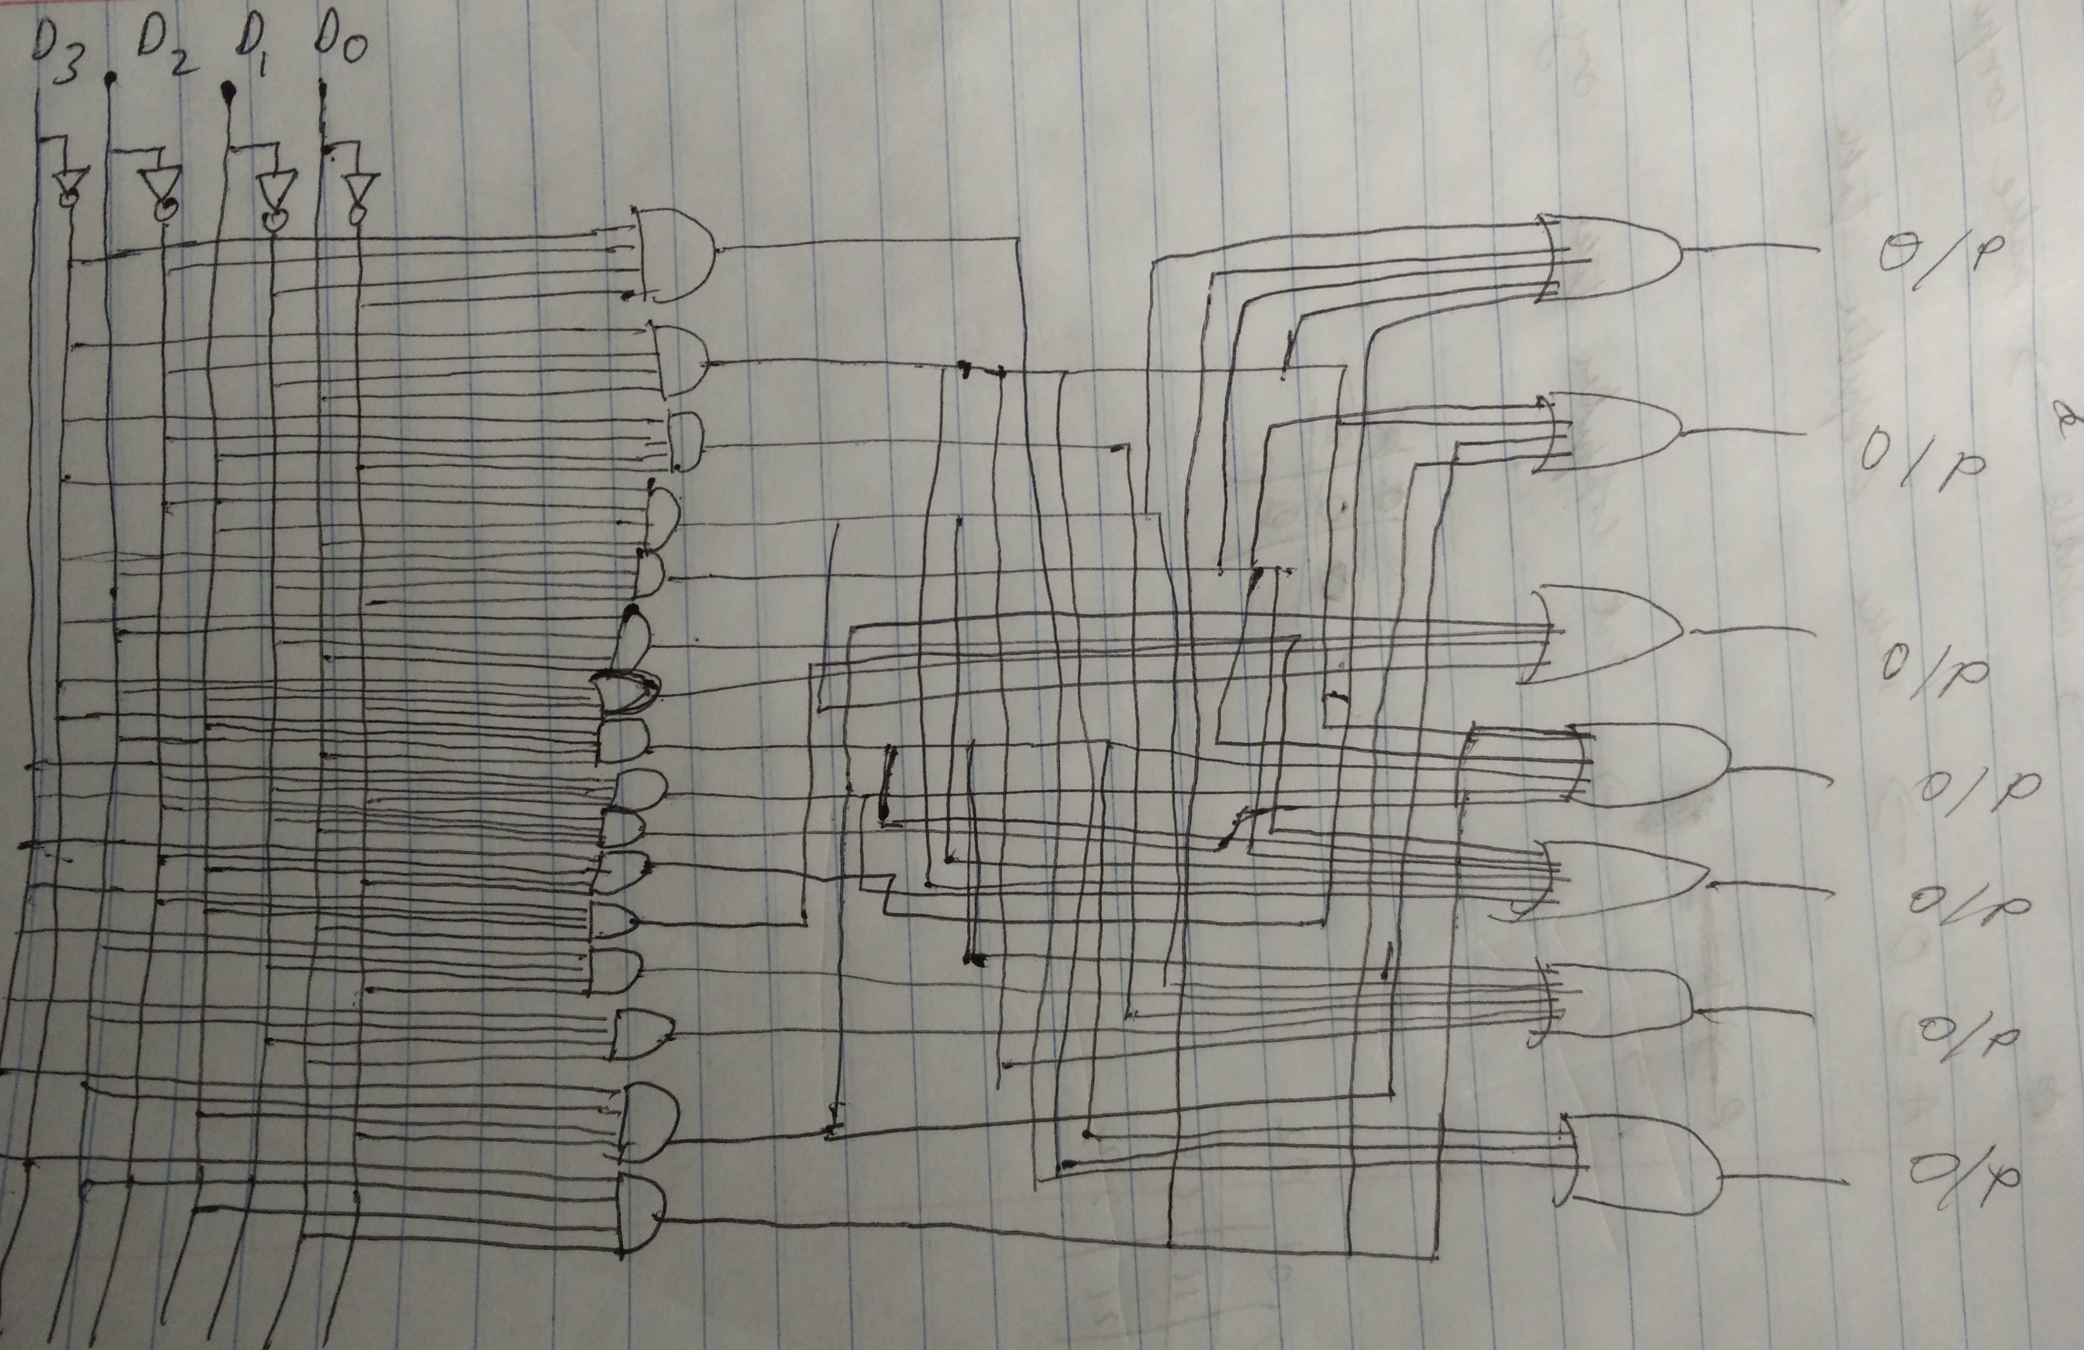

To design the schematic of the 7-segement display, we know the inputs can have two values 0 and 1 therefore putting a NOT gate with the inputs of 1 ensure us that we would get 0 the same as-well. We also know the probable outputs for the inputs. For example to display the number 1 we need in inputs to be 0 0 0 1 for D3,D2,D1 and D0 respectively. Similarly making an equation for the same we know “a” can be made from D3(not) D2(not) D0(not) D2 D0 and D1(not) , from the equations above we can find where OR and AND gates are required and create a circuit which gives us the required outputs for our inputs.

**Diagram:**

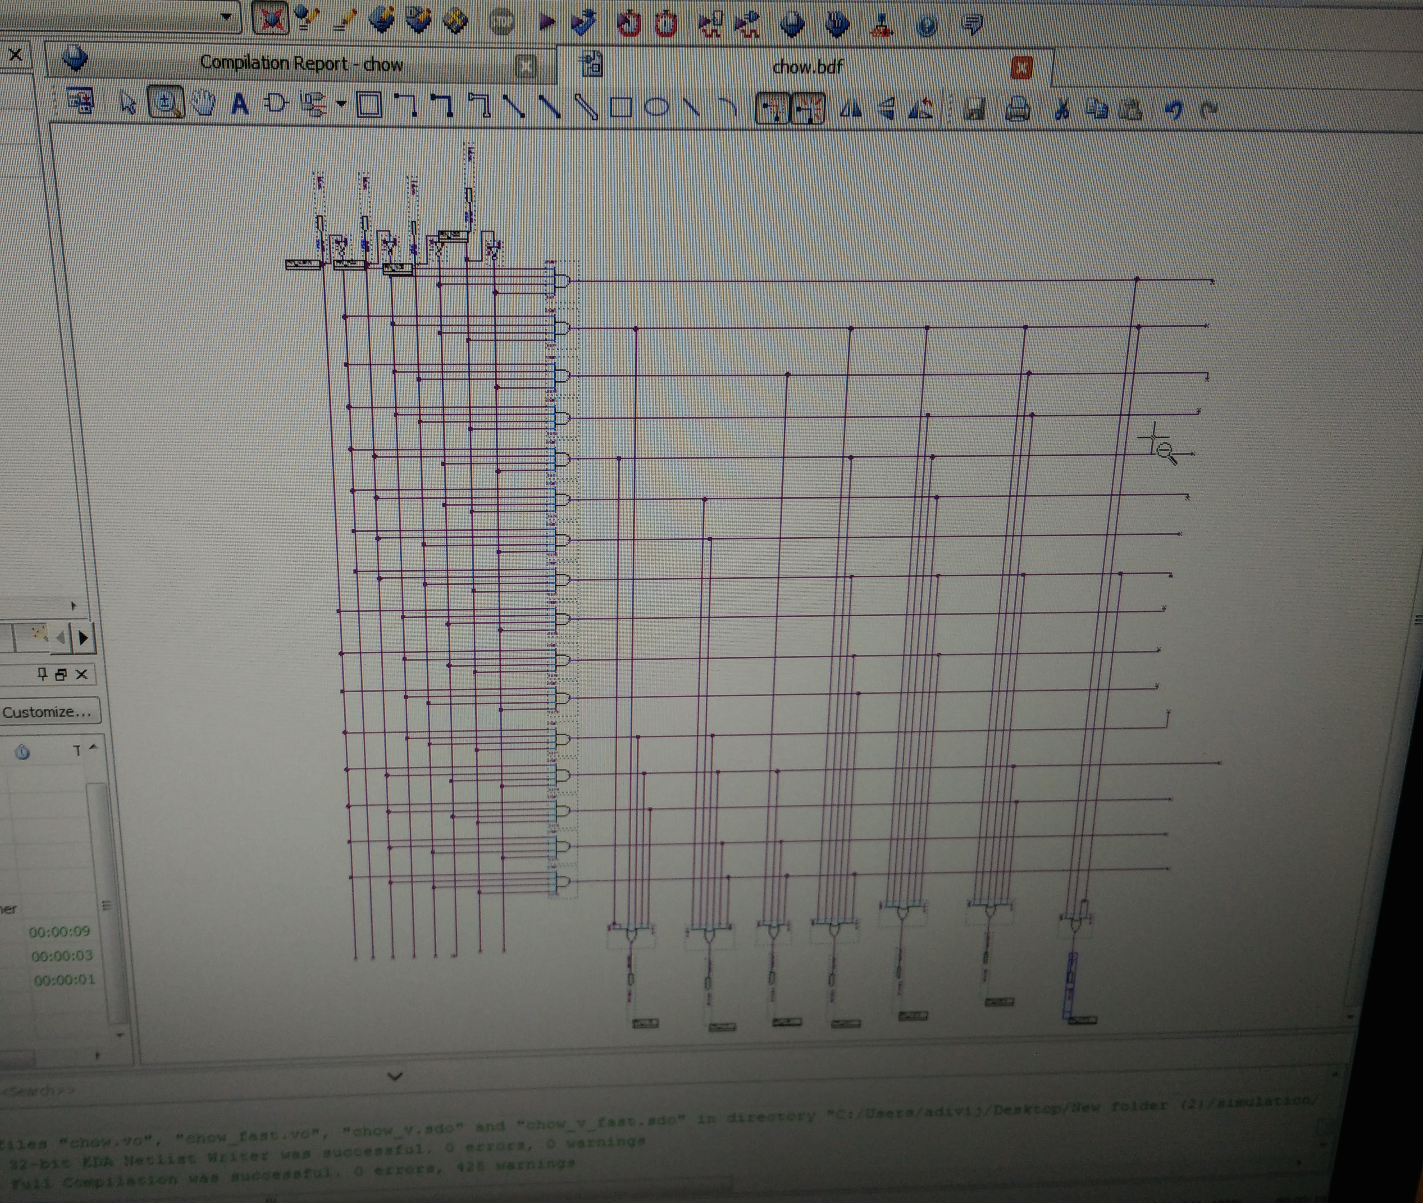

**Waveforms:**

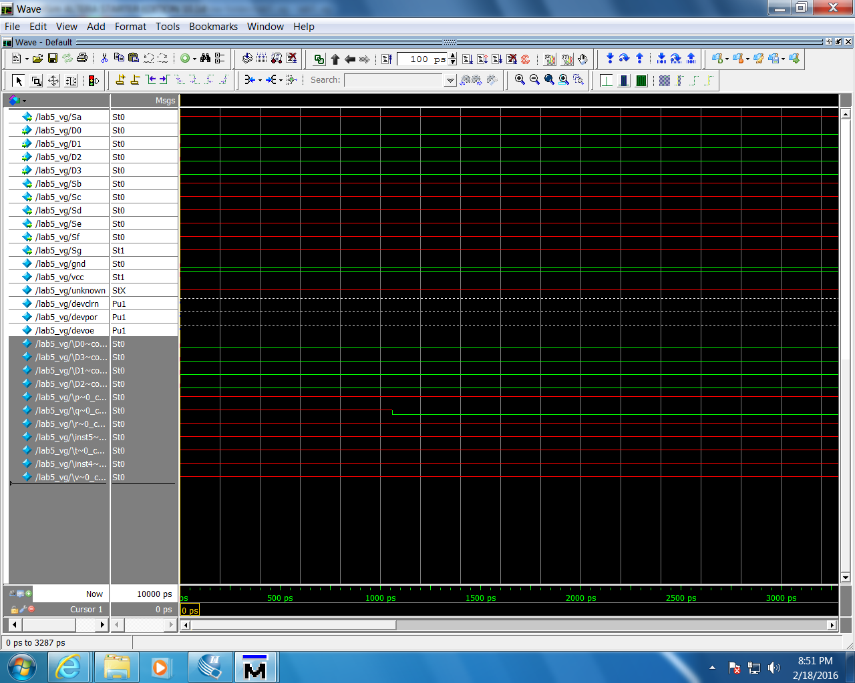

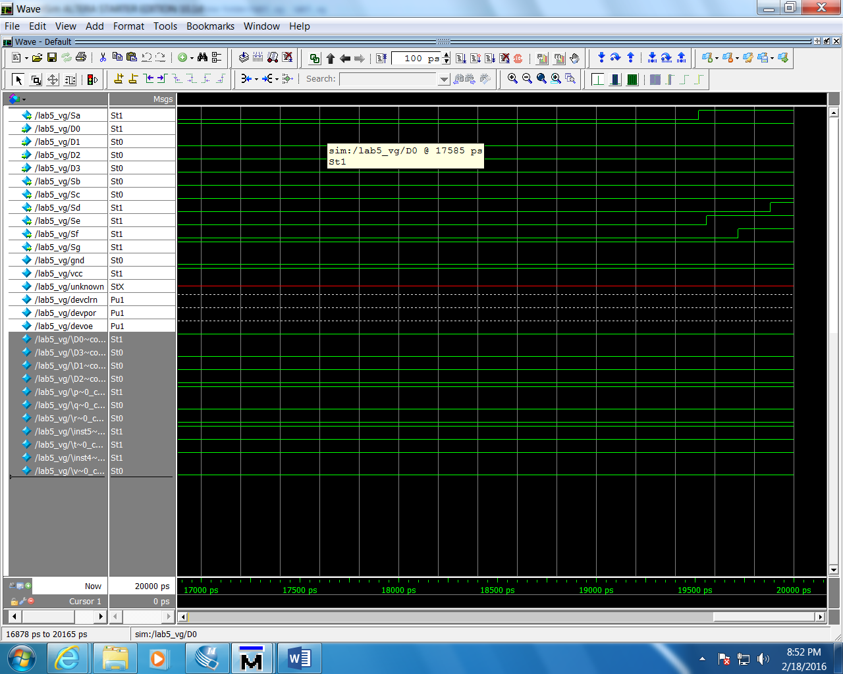

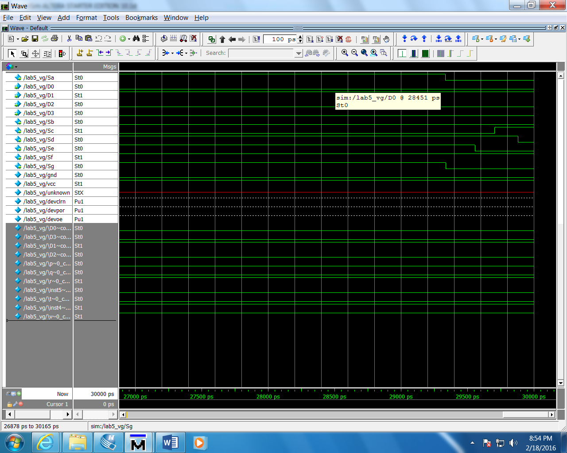

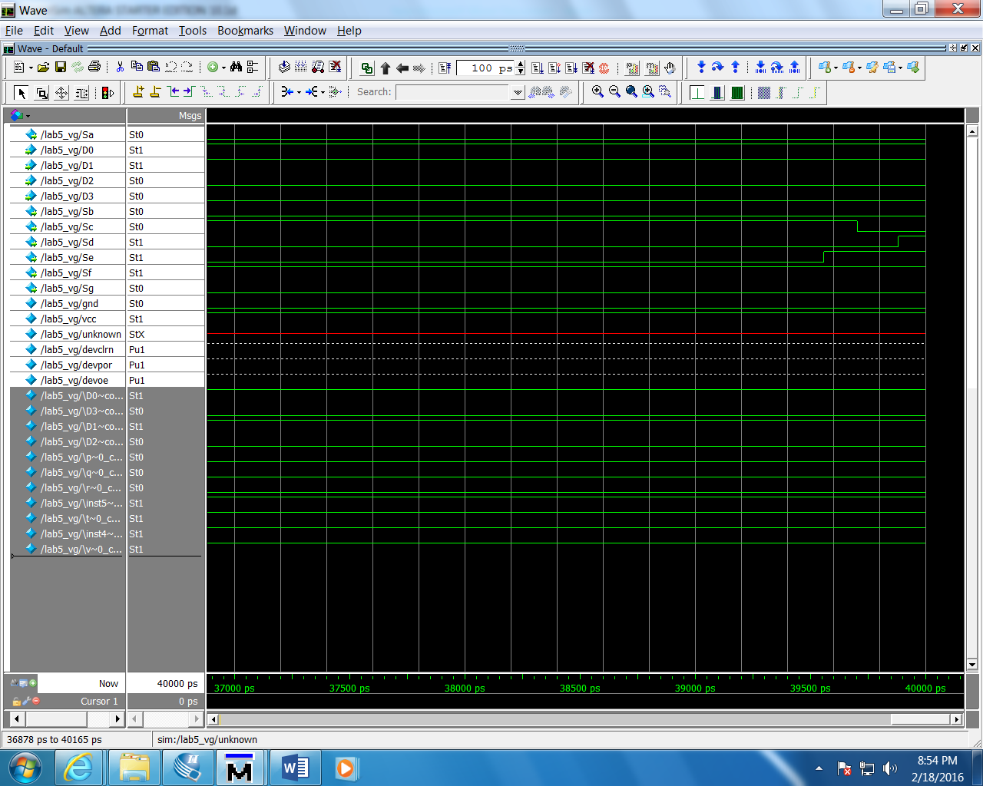

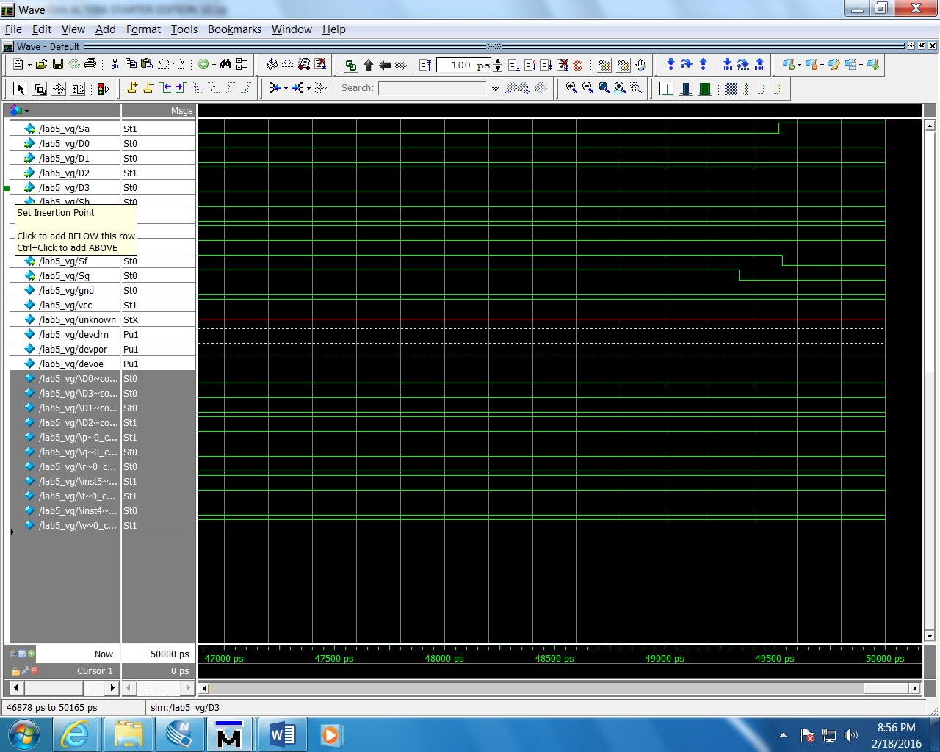

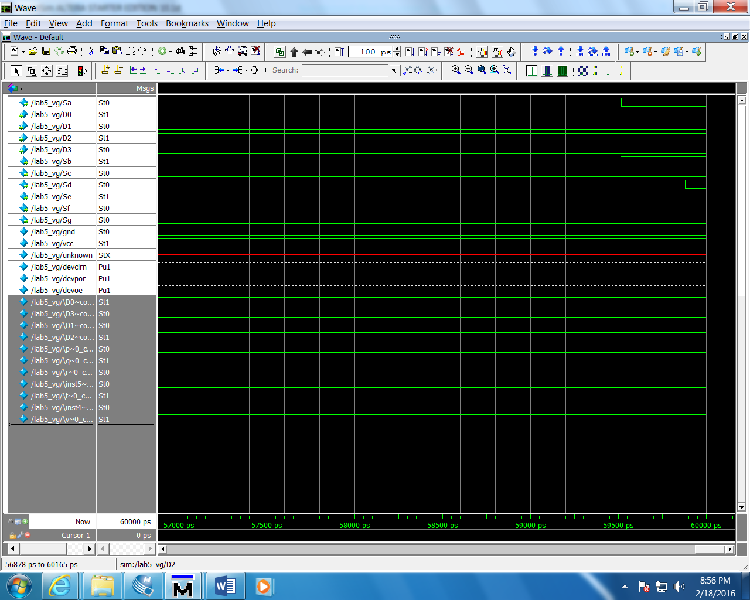

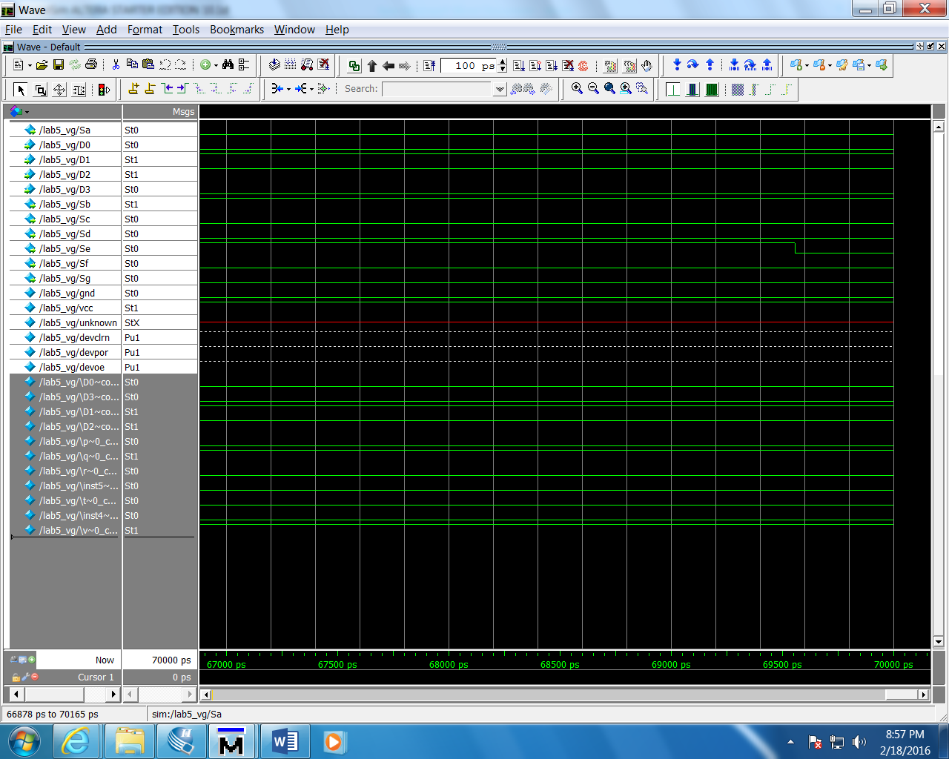

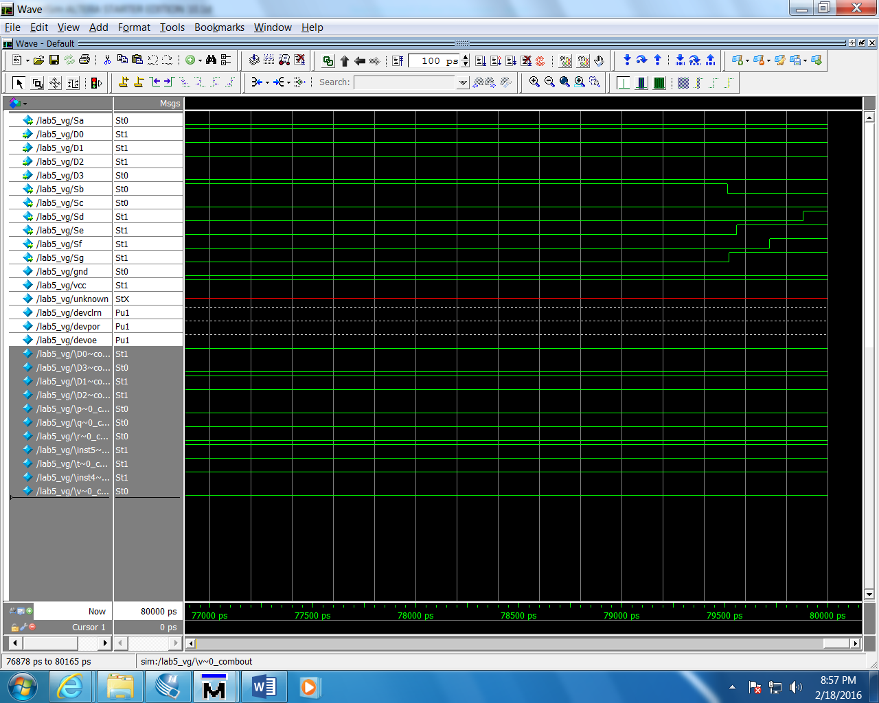

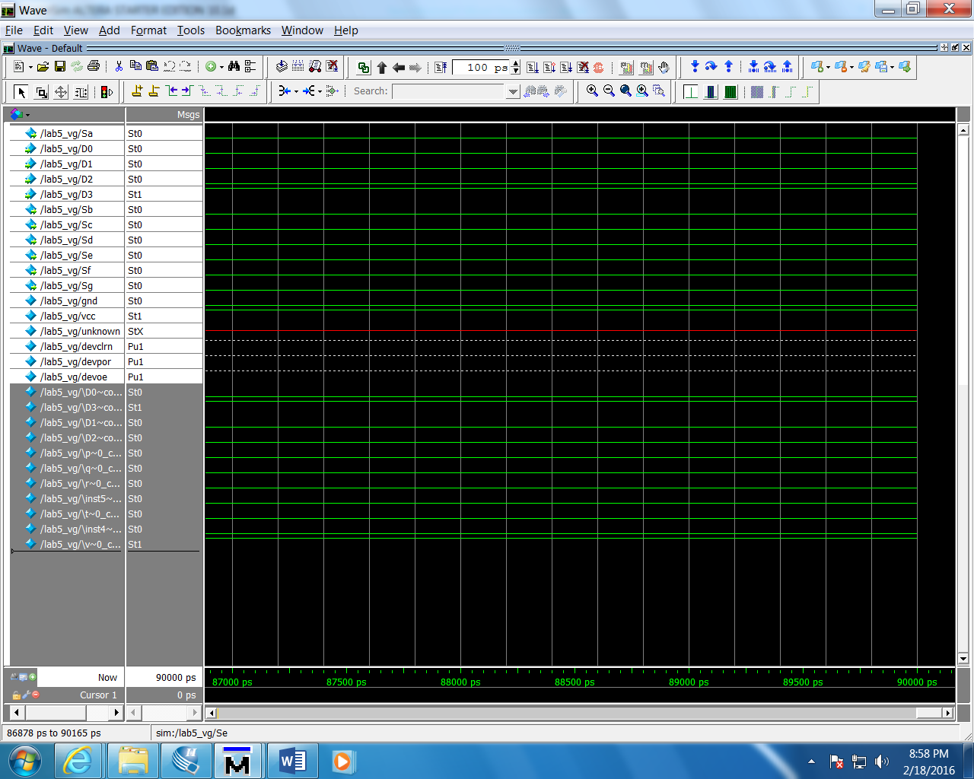

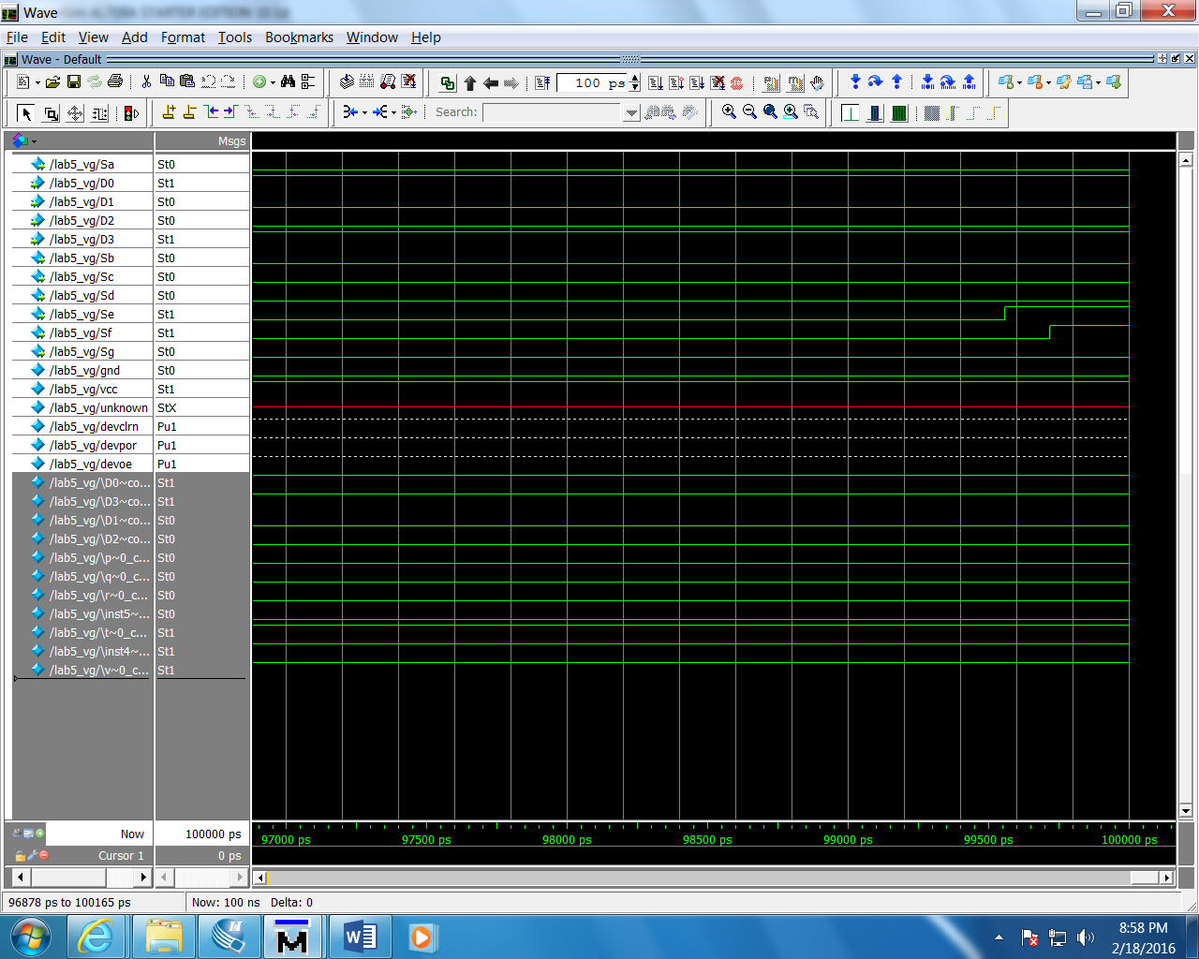

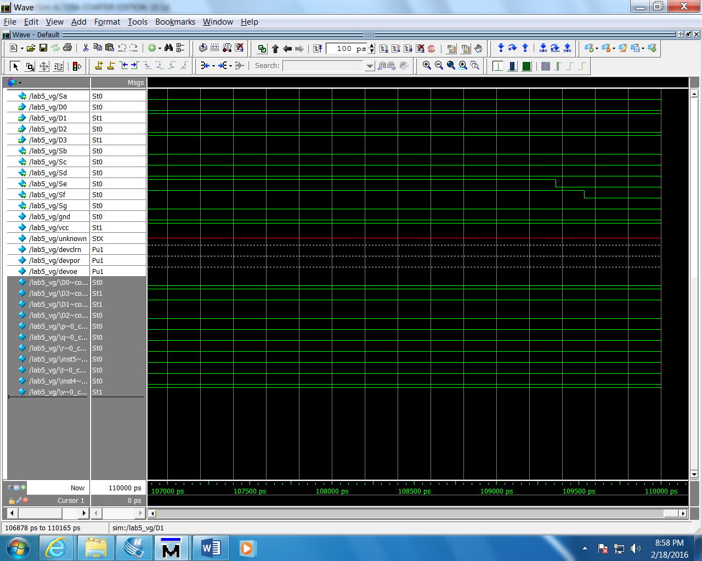

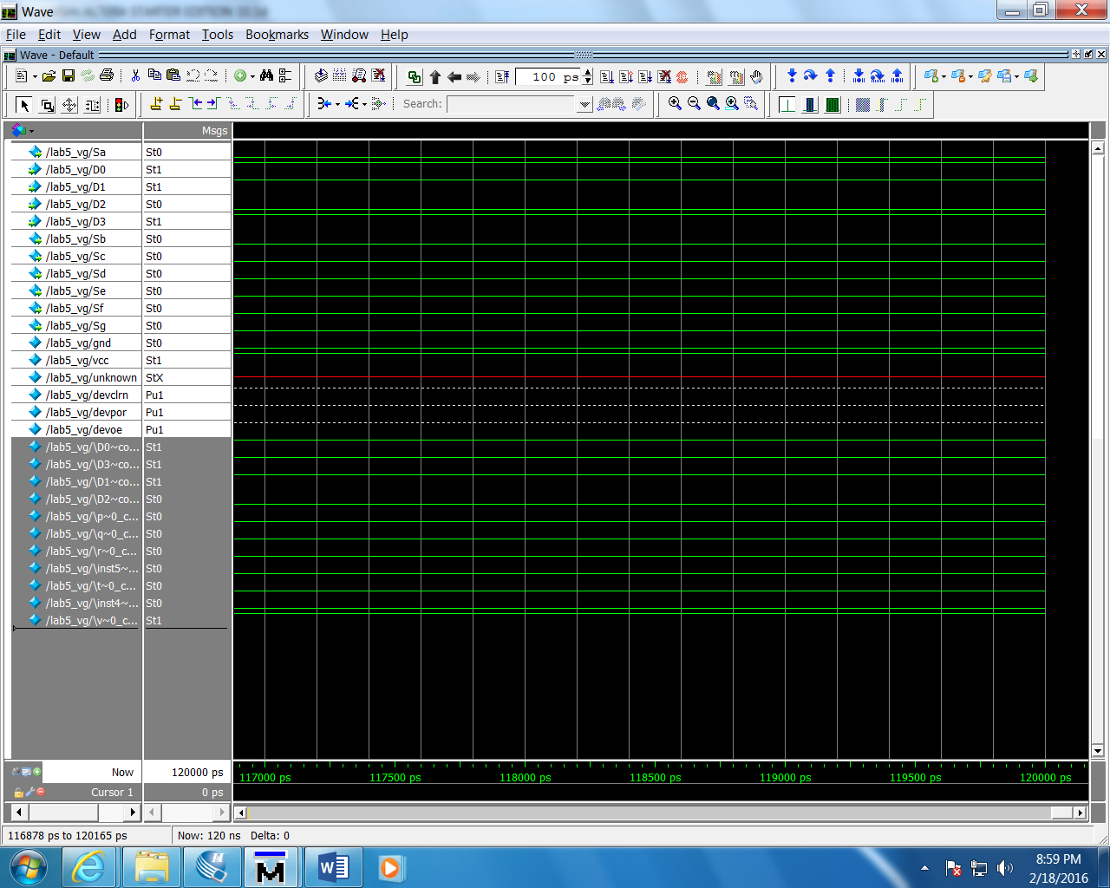

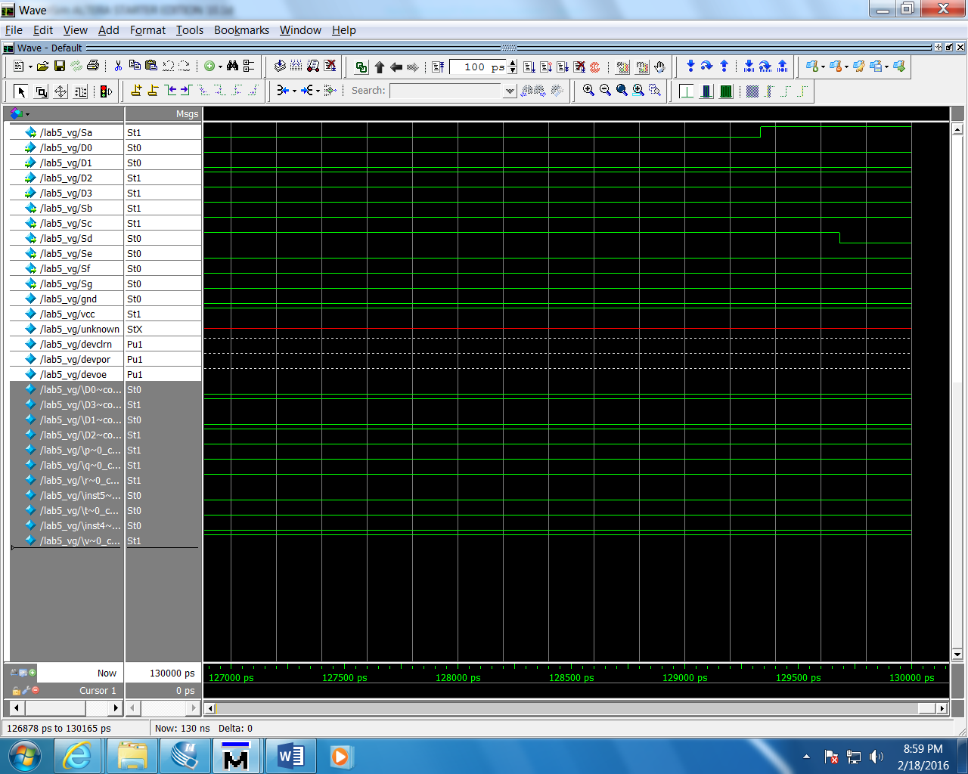

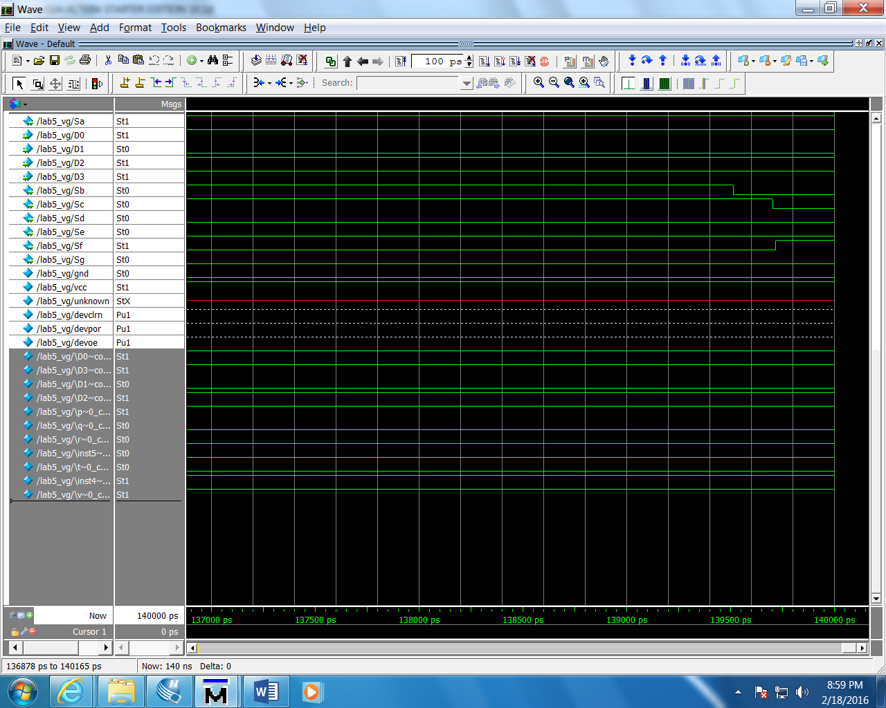

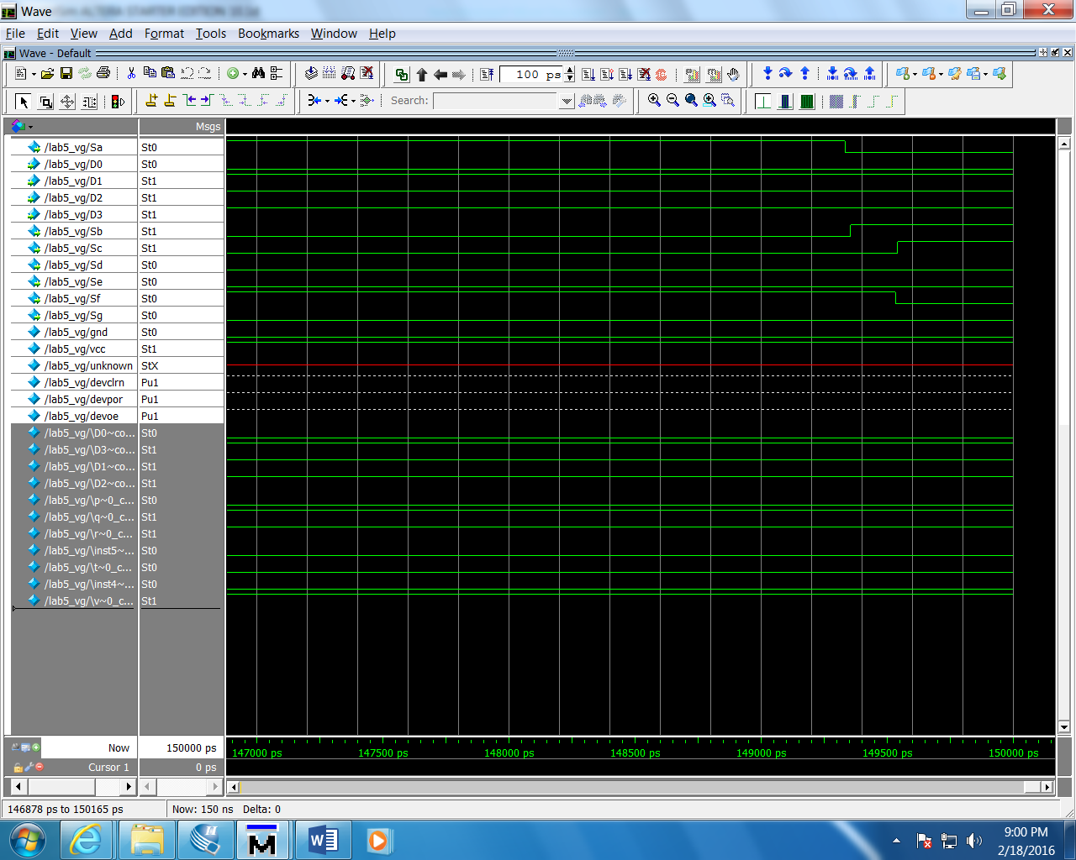

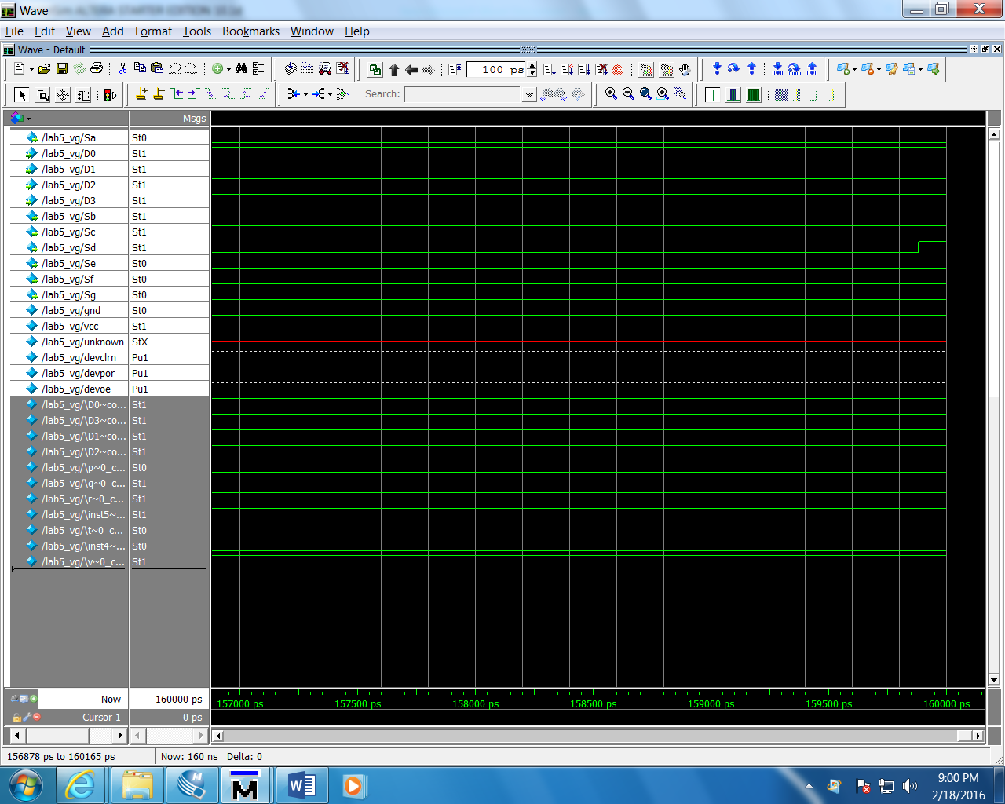

**On Board:**

